CAR PRICE PREDICTION

pip install ydata-profiling

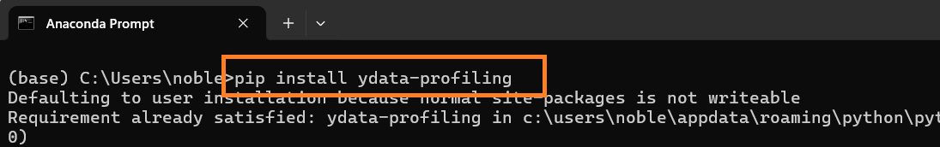

pip install pandas-profiling

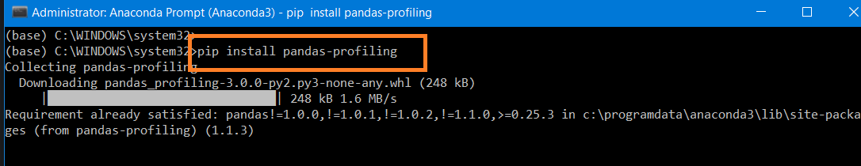

pip install visions

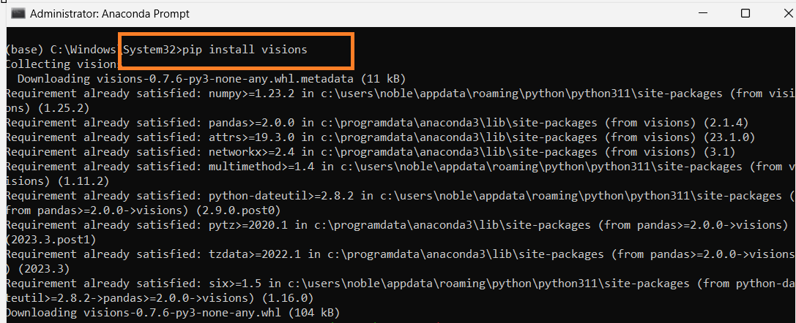

If Profiling is not working and getting an error use the following statement to install pandas profiling

# TypeError: concat() got an unexpected keyword argument 'join_axes' | Pandas Profiling

pip install <https://github.com/pandas-profiling/pandas-profiling/archive/master.zip>

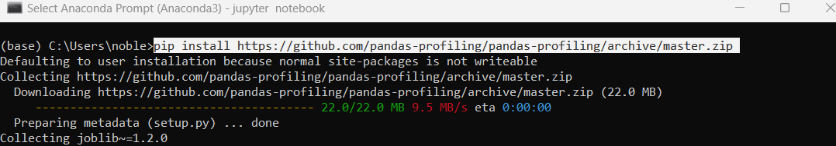

conda install conda-forge::catboost

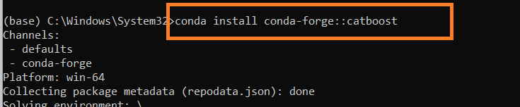

Data Set: **audi.csv**

Dependent variable: **price**

**Import Library**

import numpy as np

import pandas as pd

import matplotlib.pyplot as plt

import os

import warnings

warnings.filterwarnings('ignore')

**Check Current Directory**

print (os.getcwd())

**Change the directory**

os.chdir ('C:\\Noble\\Training\\Acmegrade\\Data Science\\Projects\\PRJ Car Price Prediction\\')

print (os.getcwd())

**Read Data, display records**

df=pd.read_csv("audi.csv")

display(df)

Automated Exploratory Data Analysis (EDA)

**Pandas Profiling Report**

import ydata_profiling as pf

display(pf.ProfileReport(df))

Manual EDA

**Number of records**

print (len(df))

**Number of records- Shape**

display (df.shape)

**Checking the data types**

display (df.dtypes )

**Checking null values**

display (df.isna().sum() )

**Data set details – Info**

print (df.info())

**Data set details – Describe**

display (df.describe ())

**Create X**

X = df.iloc[:,[0,1,3,4,5,6,7,8]].values

display (X.shape)

display (X)

**Create Y**

Y = df.iloc[:,[2]].values

display (Y.shape)

display (Y)

**Display Top 5 - X variable**

display(pd.DataFrame(X).head(5))

**Label Encoding Column – Model and Fuel Type**

from sklearn.preprocessing import LabelEncoder

le1 = LabelEncoder()

X[:,0] = le1.fit_transform(X[:,0])

le2 = LabelEncoder()

X[:,-4] = le2.fit_transform(X[:,-4])

display (X)

**One hot Encoding to column – transmission**

from sklearn.preprocessing import OneHotEncoder

from sklearn.compose import ColumnTransformer

ct = ColumnTransformer(transformers = [('encoder',OneHotEncoder(),[2])],remainder='passthrough')

X = ct.fit_transform(X)

display (X.shape)

display (pd.DataFrame(X))

**Display – X**

display (pd.DataFrame(X))

**Features Scaling – Standardization**

**f**rom sklearn.preprocessing import StandardScaler

sc = StandardScaler()

X = sc.fit_transform(X)

display (pd.DataFrame(X))

**Train Test Split**

from sklearn.model_selection import train_test_split

(X_train,X_test,Y_train,Y_test) = train_test_split(X,Y,test_size=0.2,random_state=0)

print (X.shape, Y.shape)

print (X_train.shape, Y_train.shape)

print (X_test.shape, Y_test.shape)

**Create Random Forest Regressor**

from sklearn.ensemble import RandomForestRegressor

regression = RandomForestRegressor(random_state=0)

regression.fit(X_train,Y_train)

display (regression)

**Prediction with Test Data**

y_pred = regression.predict(X_test)

display (y_pred)

**Display actual and Predicted Values**

print (pd.concat ([pd.DataFrame(Y_test.reshape(len(Y_test),1),columns =['Car Price']),

pd.DataFrame(y_pred.reshape(len(y_pred),1),columns =['Price Prediction'])],axis =1))

**Display – Accuracy and Mean Absolute Error**

from sklearn.metrics import r2_score,mean_absolute_error

print ('R2 Score ', r2_score(Y_test, y_pred))

print ('Mean Absolute Error', mean_absolute_error(Y_test,y_pred))

**Prediction with Complete Data**

f_pred = regression.predict(X)

display (f_pred)

**Display actual and Predicted Values**

display(pd.concat ([df,pd.DataFrame(f_pred.reshape(len(f_pred),1),columns =['Price Prediction'])],axis =1))

**Display – Accuracy and Mean Absolute Error**

from sklearn.metrics import r2_score,mean_absolute_error

print ('R2 Score ', r2_score(Y, f_pred))

print ('Mean Absolute Error', mean_absolute_error(Y,f_pred))

**Create a Linear Regression Model**

from sklearn.linear_model import LinearRegression

reg = LinearRegression()

reg.fit(X_train,Y_train)

print(reg)

**Prediction with Test Data**

y_pred = reg.predict(X_test)

display (y_pred)

**Display actual and Predicted Values (Test Data)**

print (pd.concat ([pd.DataFrame(Y_test.reshape(len(Y_test),1),columns =['Car Price']),

pd.DataFrame(y_pred.reshape(len(y_pred),1),columns =['Price Prediction'])],axis =1))

**Display – Accuracy and Mean Absolute Error**

from sklearn.metrics import r2_score,mean_absolute_error

print ('R2 Score ', r2_score(Y_test, y_pred))

print ('Mean Absolute Error', mean_absolute_error(Y_test,y_pred))

**Prediction for complete data set**

f_pred = reg.predict(X)

display (f_pred)

**Display the Actual and predicted data**

result = pd.concat([df,pd.DataFrame(f_pred,columns = ['Price Prediction'])],axis=1)

display( result)

**Display – Accuracy and Mean Absolute Error**

from sklearn.metrics import r2_score,mean_absolute_error

print ('R2 Score ', r2_score(Y, f_pred))

print ('Mean Absolute Error', mean_absolute_error(Y,f_pred))

**Create Model Extra Tree Regressor**

from sklearn.ensemble import ExtraTreesRegressor

ET_Model=ExtraTreesRegressor(n_estimators = 120)

ET_Model.fit(X_train,Y_train)

y_predict=ET_Model.predict(X_test)

from sklearn.metrics import r2_score,mean_absolute_error

print ('R2 Score ', r2_score(Y_test, y_predict))

print ('Mean Absolute Error', mean_absolute_error(Y_test,y_predict))

**Display the Result Complete Data**

f_pred = ET_Model.predict(X)

display (f_pred)

result = pd.concat([df,pd.DataFrame(f_pred,columns = ['Price Prediction'])],axis=1)

display( result)

**Display – Accuracy and Mean Absolute Error**

from sklearn.metrics import r2_score,mean_absolute_error

print ('R2 Score ', r2_score(Y, f_pred))

print ('Mean Absolute Error', mean_absolute_error(Y,f_pred))

**Install Cat boost**

pip install catboost

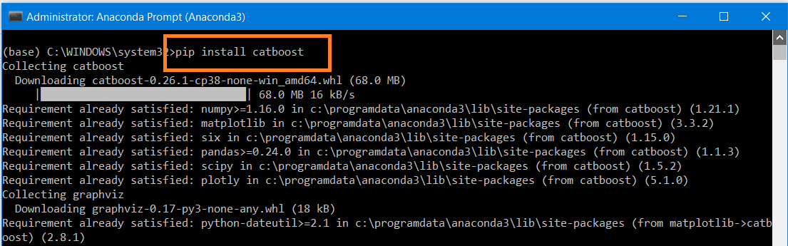

**Model CatBoostRegressor**

from catboost import CatBoostRegressor

cat=CatBoostRegressor()

print (cat.fit(X_train,Y_train))

**Cat Boost Prediction test Data**

cat_pred=cat.predict(X_test)

display (cat_pred)

**Cat Boost Accuracy**

print ('Mean Absolute Error', mean_absolute_error(Y_test,cat_pred))

print ('R2 Score ', r2_score(Y_test,cat_pred))

**Prediction Complete Data**

catf_pred = cat.predict(X)

display (catf_pred )

**Display the result**

result = pd.concat([df,pd.DataFrame(catf_pred ,columns = ['Price Prediction'])],axis=1)

display( result)

**Display the Accuracy and Error**

from sklearn.metrics import r2_score,mean_absolute_error

print ('R2 Score ', r2_score(Y, catf_pred))

print ('Mean Absolute Error', mean_absolute_error(Y,catf_pred))

**RandomizedSearchCV**

# Hyperparameter Tuning and RandomizedSearchCV - Model used – RandomForestRegressor

from sklearn.model_selection import RandomizedSearchCV

n_estimators = [int(x) for x in np.linspace(start = 80, stop = 1500, num = 10)]

max_features = ['auto', 'sqrt']

max_depth = [int(x) for x in np.linspace(6, 45, num = 5)]

min_samples_split = [2, 5, 10, 15, 100]

min_samples_leaf = [1, 2, 5, 10]

# create random grid

rand_grid={'n_estimators': n_estimators,

'max_features': max_features,

'max_depth': max_depth,

'min_samples_split': min_samples_split,

'min_samples_leaf': min_samples_leaf}

rf=RandomForestRegressor()

rCV=RandomizedSearchCV(estimator=rf,param_distributions=rand_grid,scoring='neg_mean_squared_error',n_iter=10,cv=5,random_state=42, n_jobs = -1)

**Fit Model**

display (rCV.fit(X_train,Y_train))

**Prediction**

rf_pred=rCV.predict(X_test)

display (rf_pred)

**Mean_absolute_error and mean_squared_error**

from sklearn.metrics import mean_absolute_error,mean_squared_error

print('MAE',mean_absolute_error(Y_test,rf_pred))

print('MSE',mean_squared_error(Y_test,rf_pred))

**Display Accuracy**

display (r2_score(Y_test,rf_pred))

**Display the Result Complete the Data**

full_rf_pred=rCV.predict(X)

display (full_rf_pred)

**Display Error and accuracy**

from sklearn.metrics import mean_absolute_error,mean_squared_error

print('MAE',mean_absolute_error(Y,full_rf_pred))

print('MSE',mean_squared_error(Y,full_rf_pred))

display (r2_score(Y,full_rf_pred))

**Create Pickle File**

#Use pickle to save our model so that we can use it later

import pickle

# Saving model to disk

pickle.dump(cat, open('model.pkl','wb'))

**Load Pickle File and do Prediction**

model=pickle.load(open('model.pkl','rb'))

p_pred = model.predict (X)

print (p_pred)

**Display the result**

result = pd.concat([df,pd.DataFrame(p_pred ,columns = ['Price Prediction'])],axis=1)

display( result)

**Display the Accuracy and Error**

from sklearn.metrics import r2_score,mean_absolute_error

print ('R2 Score ', r2_score(Y, p_pred))

print ('Mean Absolute Error', mean_absolute_error(Y,p_pred))

**Open in a New File**

**Import Required Libraries**

import numpy as np

import pandas as pd

import os

**Check the current working directory**

print (os.getcwd())

**Change working directory**

os.chdir ('C:\\Noble\\Training\\Acmegrade\\Data Science\\Projects\\PRJ Car Price Prediction\\')

print (os.getcwd())

**Read the Data File**

df=pd.read_csv("audi.csv")

display(df)

**Create X**

X = df.iloc[:,[0,1,3,4,5,6,7,8]].values

display (X.shape)

display (X)

**Create Y**

Y = df.iloc[:,[2]].values

display (Y.shape)

display (Y)

**Label Encoding**

from sklearn.preprocessing import LabelEncoder

le1 = LabelEncoder()

X[:,0] = le1.fit_transform(X[:,0])

le2 = LabelEncoder()

X[:,-4] = le2.fit_transform(X[:,-4])

display (X)

**One hot encoder**

from sklearn.preprocessing import OneHotEncoder

from sklearn.compose import ColumnTransformer

ct = ColumnTransformer(transformers = [('encoder',OneHotEncoder(),[2])],remainder='passthrough')

X = ct.fit_transform(X)

display (X.shape)

display (pd.DataFrame(X))

**Standardisation**

from sklearn.preprocessing import StandardScaler

sc = StandardScaler()

X = sc.fit_transform(X)

display (pd.DataFrame(X))

**Import Pickle File and Prediction**

import pickle

model=pickle.load(open('model.pkl','rb'))

p_pred = model.predict (X)

print (p_pred)

**Display the result**

result = pd.concat([df,pd.DataFrame(p_pred ,columns = ['Price Prediction'])],axis=1)

display( result)

**Display Error and Accuracy**

from sklearn.metrics import r2_score,mean_absolute_error

print ('R2 Score ', r2_score(Y, p_pred))

print ('Mean Absolute Error', mean_absolute_error(Y,p_pred))